

**US Army Corps of Engineers**

**Afghanistan Engineer District**

AED Design Requirements: WWTP EFFLUENT AND GRAY WATER REUSE SYSTEMS

Various Locations, Afghanistan

SEPTEMBER 2009 Version 1.0

**TABLE OF CONTENTS**

AED DESIGN REQUIREMENTS FOR

WWTP EFFLUENT AND GRAY WATER REUSE SYSTEMS VARIOUS LOCATIONS,

AFGHANISTAN

Section Page

**1. General 1**

**2. Reuse Water Quality Standards for Landscape Irrigation 1** a) Sources 1 b) Provisions for Cross connection and Exposure Control 2 c) Setback Distances 2

**3. WWTP Effluent Reuse Systems 2** a) Volume and Quality/Exposure Determination 2 b) Treatment Requirements 2 c) Storage Requirements 3 d) Provisions for Cross Connection and Exposure Control 3 e) Distribution System Requirements 3

**4. Gray Water Reuse Systems 5** a) Volume and Quality/Exposure Determination 5 b) Treatment Requirements 5 c) Storage Requirements 5 d) Provisions for Cross Connection and Exposure Control 6 e) Distribution System Requirements

(1) Decentralized Distribution 6 (2) Centralized Distribution 6 (3) System Design Requirements 7

**5. Reuse Systems Under Athletic Fields 8**

**6. Design Submittal Information 8**

**7. As-Builts 9**

**8. References 10**

Figures

Figure 1. Reclaimed Water Definitions 3

Figure 2. De-centralized Gray Water System Concept 6

Figure 3. Centralized Gray Water System Concept 7

Tables

Table 1. Reclaimed Water Quality Standards for Landscape Irrigation 1

Table 2. Treated WWTP Effluent Application Rates 4

Table 3. Effluent Void Volume for Gravel Line Landscaped Beds (to be updated) 5

Table 4. Minimum Gray Water Gravity Drain Pipe Slopes 7

Table 5. Effluent Application Allowances 7

Table 6. Summary of WWTP Effluent & Gray Water Reuse Design Submittal Data 8

i

**1. General**

Water conservation through reclamation and reuse are key components to overall water management in Afghanistan. Potential sources of water for reuse at AED projects include effluent from secondary treatment wastewater treatment plants (WWTPs) (package WWTPs and activated sludge plants), effluent from primary treatment WWTPs (septic tanks and lagoons), waste water collected from non sewage containing sources (showers and sinks) and raw sewage. Raw sewage is not a viable

source of water reclamation and will not be discussed in this guidance document.

**2. Reclaimed Water.**

a) Sources. Sources of reclaimed water for reuse are typically divided into three categories: WWTP effluent, gray water, and black water. The purpose of this document is to provide design and submittal documentation requirements to contractors for projects requiring water reclamation through collection and reuse of the effluent from WWTPs and gray water systems. Table 1 provides the definition of each category of water subject to reclamation within AED, its sources, degree of health hazard associated with its reuse, typical types of reuse, and minimum water quality necessary for reuse.

**Table 1 Reclaimed Water Definitions**

|  |  |  |  |  |
| --- | --- | --- | --- | --- |
| **Type of Water to be Reclaimed** | **Source** | **Health Hazard** | **Reuse**  **Opportunities** | **Water Quality Required for Reuse in AED** |
| Wastewater Treatment Plant Effluent | Effluent from an engineered, wastewater treatment plant with secondary treatment. Effluent is properly chlorinated to kill bacteria and discharged with a measurable residual. | **Minimal**  Non-potable water with potential health hazard if recontaminated. | All types of landscape and orchard or vineyard irrigation | pH = 6-9; BOD5 less than 5 mg/L;  turbidity less than 2  NTU; detectable chlorine residual after 30 minutes; no detectable fecal coliform |
| Gray Water | Shower and bath  wastewater, bathroom sink water, kitchen sink wastewater, and laundry wastewater. Gray water does not mean toilet or urinal waste or garbage wastes (Note 1), or wastewater from septic tanks, lagoons, or stabilization ponds. | **High**  Contains bacteria, is highly subject to recontamination and is  potentially a serious health hazard. | None without additional treatment including chlorination. | BOD5 less than 30 mg/L; TSS less than  30 mg/L; detectable chlorine residual after 30 minutes; fecal coliform geometric mean number less than  1000 per ml (Note 2) |
| Black Water | Raw sewage and effluent from primary wastewater  treatment facilities – septic tanks, lagoons and stabilization ponds – without chlorination. | **Extreme** | None. | Not applicable without further treatment to levels cited for WWTP Plant Effluent |

Notes: 1. Oregon, HB2080A, June 2009.

2. Army, TB MED 593, Guidelines for Field Waste Management, September 2006.

3. Based on Reference 5, Table 8

b) Provisions for Cross Connection and Exposure Control. Horizontal and vertical separation requirements between potable water and reclaimed water systems shall be the same as between potable water and sanitary sewer pipe lines. These are stated below:

The Contractor shall ensure that the reclaimed effluent or gray water system design meets the following criteria:

1) Reclaimed water pipes shall be located no closer than 30m (100 feet) horizontally to water wells or reservoirs to be used for potable water supply.

2) Reclaimed water pipes shall be no closer than 3 m (10 feet) horizontally to potable water lines; where the bottom of the water pipe will be at least 300mm (12 inches) above the top of the sanitary sewer, horizontal spacing shall be a minimum of 1.8m (6 feet).

3) Reclaimed water pipes crossing above potable water lines shall be constructed of suitable pressure pipe or fully encased in concrete for a distance of 2.7m (9 feet) on each side of the crossing. Pressure pipe will be as required for force mains in accordance with the contract standards and shall have no joint closer than 1m (3 ft) horizontally to the crossing, unless the joint is fully encased in concrete.

All reclaimed water pipe shall be colored green to designate effluent reuse water. In addition to color coding pipe, warning signs shall be shown at the outside the building or facility that is the point of wastewater generation notifying personnel that reclaimed water used on the installation is not safe for human consumption, and an education sheet shall be provided for the staff to educate workers on sanitation precautions (washing hands, avoiding ingestion, etc.) when handling reclaimed water equipment, and about avoiding cross contamination by connecting reclaimed water lines with potable water supply.

c) Setback Distances. Both Reclaimed WWTP effluent and gray water distribution systems have the potential to pollute nearby potable water wells. Setback distances are therefore required to minimize this potential. The required setback distance between potable water wells and reclaimed WWTP effluent distribution systems is 15 meters. The required setback distance between potable water wells for gray water distribution systems is 30 meters.

**3. WWTP Effluent Reuse Systems**

a) Volume and Quality/Exposure Determination. The anticipated need and method of WWTP effluent reuse shall be determined prior to design of an effluent storage and reuse system. The quality of effluent required will vary depending on the planned reuse of the reclaimed water. For example, a high degree of bacteriological monitoring is necessary when the reclaimed WWTP effluent will be used in applications with high potential for human contact. A controlled and less stringently monitored chlorinated effluent can be accepted when the application is the subsurface irrigation of trees and plants with no human contact. Health monitoring plans and routine water testing shall insure that the water always meets health requirements prior to use and exposure of workers.

b) Treatment Requirements. Minimum WWTP effluent treatment levels are listed in Table 1. Effluent disinfection equipment shall be designed to provide a minimum residual of 1 mg/l when discharged from the WWTP effluent disinfection system. All reclaimed WWTP effluent systems shall include design features to allow manual bypass to an outfall or discharge point other than the receiving reclamation or reuse system. This is necessary so that an appropriate discharge point is available when there is a malfunction or failure of the WWTP. An example schematic based on a reclaimed WWTP reclamation system constructed by USACE-AED is shown in Figure 1. General design requirements for a package WWTP and/or lagoon system necessary for this system is provided in Reference 7.

**Figure 1. Example Reclaimed WWTP Effluent System Concept**

IRRIGATION USE

c) Storage Requirements. WWTP effluent storage for reclamation should be based on the anticipated volume requirements determined by preparing a water budget analysis for the anticipated use. In no case should the storage be greater than the 24-hour average daily flow used in the design of the WWTP system. The potential for recontamination with harmful bacteria is high when reclaimed WWTP effluent is stored for longer than 24 hours. Longer storage is permitted as long as there is adequate chlorine residual monitoring, mixing capacity and the ability to add chlorine if the residual drops below required levels prior to use.

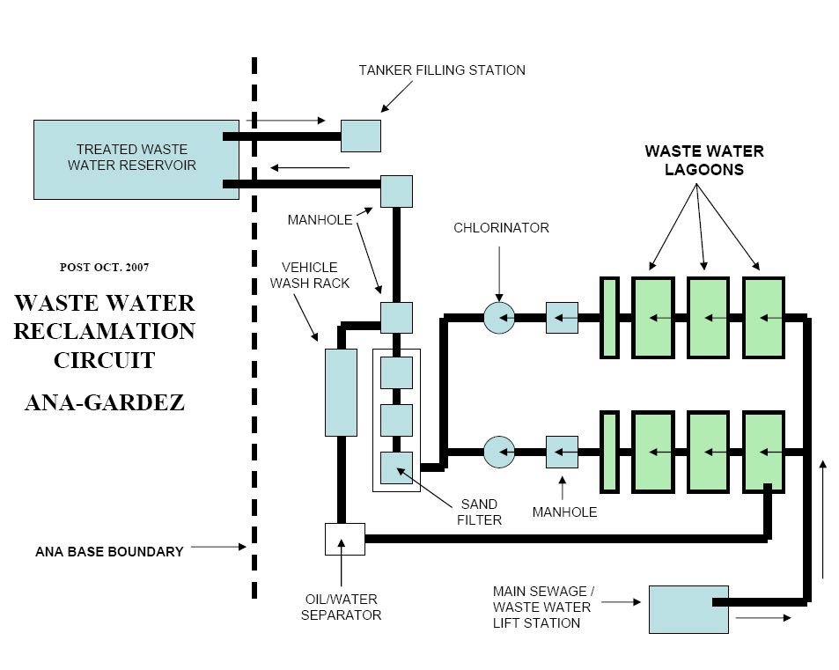

d) Provisions for Cross Connection and Exposure Control. Horizontal and vertical separation requirements between potable water and reclaimed gray water systems shall be the same as between potable water and sanitary sewer pipe lines. These requirements were outlined in the previous section.

e) Distribution System Requirements. Although a gravity dosing system constructed similarly to those used in septic tank effluent leach fields may be constructed, reclaimed WWTP effluent reuse normally incorporates the use of a pressure dosing system. Smaller orifices and pressurized dosing insures even distribution throughout the distribution system. The preferred application means is subsurface perforated pipe, drip emitters, surface bubblers, or low pressure sprinklers.

Perforated pipe diameters used in reclaimed WWTP effluent distribution field laterals should be nominal 25 to 50 mm (1 to 2 inch) in size, Schedule 40 or 80 PVC (ASTM 1785),or equivalent. Orifice diameters should be approximately 3 mm in size. Operating pressures should provide a minimum residual pressure of 14 kPa (2 psi) at each orifice. Detailed design guidance and further

information can be found in the Reference 6 which discusses pressure dosing systems.

Residual operation pressure should be limited to the minimum required for operation of the distribution system. Generally, low pressure sprinklers can operate at pressures of 241 kPa (35 psi). Drip systems and bubblers require less pressure. Operating pressures in excess of 241 kPa (35 psi) reduces the potential for cross contamination with the potable water system which is usually design to operate at a minimum of pressure of 241 kPa (35 psi).

Application of reclaimed wastewater should not exceed agronomic requirements of plant growth including leaching, and soil infiltration capacity. Agronomic application rates vary according to the plant and weather conditions (seasonal rainfall, and evapotranspiration). Table 2 provides the rates of percolation which can be anticipated due to soil infiltration. These rates are determined on the basis of percolation testing as described in Reference 6. For gray water systems, the landscaped beds to be irrigated shall have sufficient volume to contain the estimated average daily flow from the system based on the fixture basis method of computing the flow rate. Table 3 provides the minimum volume for gravel bed containment of gray water.

**Table 2 Treated WWTP Effluent Application Rates**

|  |  |
| --- | --- |
| Percolation Rate, Minutes for Water to Drop 25 mm | Water Absorption of Soil  (m2/liters/day) |
| Faster than 0.1 | Soil too coarse for sewage treatment |
| 0.1 to 5 | 0.020 |
| 6 to 15 | 0.031 |
| 16 to 30 | 0.041 |
| 31 to 45 | 0.049 |
| 46 to 60 | 0.054 |
| Slower than 60 | Soil too fine for sewage treatment |

**Table 3 Effluent Void Volume for Gravel Lined Landscaped Beds**

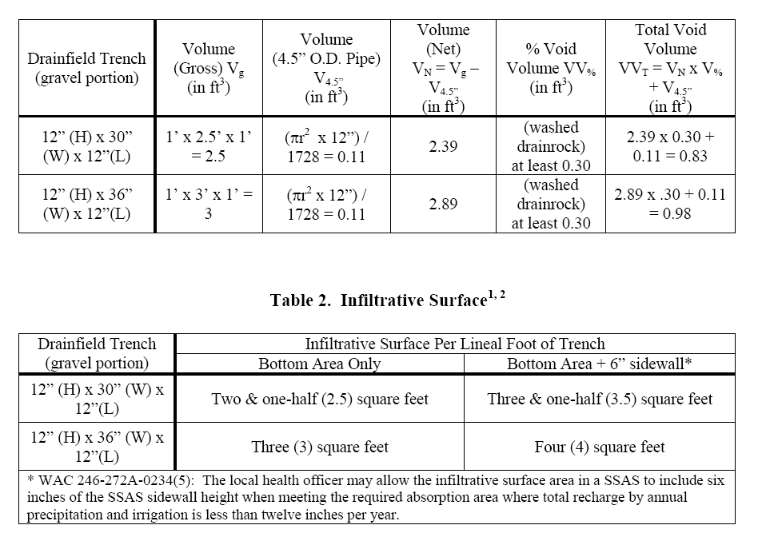

**4. Gray Water Reuse Systems**

a) Volume and Quality/Exposure Determination. The available and required volume and anticipated use for gray water shall be determined prior to design of a gray water reuse system. Gray water is untreated wastewater from showers, lavatories, laundries and floor drains. It can contain solids, pathogens, grease and oils, and possibly fecal matter. It is distinctly different in character than WWTP effluent that has received primary and secondary treatment and disinfection, The reclamation and reuse of gray water requires different design standards and more stringent exposure precautions than those required for WWTP effluent reclamation. Health monitoring plans and routine exposure analysis shall insure that health requirements are met at all times.

Contact with workers and the general base personnel must be eliminated. Coliform concentrations in gray water are initially two or three log scales lower than untreated wastewater, but will increase if the water is stored for longer than 24 hours. Septic conditions can quickly develop in stored gray water tanks. Hydrogen sulfide is generated during storage and will corrode tank lids and uncoated steel components. Gray water reuse is limited to non food plant subsurface irrigation which requires no personal contact or handling.

b) Treatment Requirements. Gray water reclamation systems shall be considered only for small decentralized systems that have provisions for a backup discharge to the sanitary sewer system.

Gray water requires no additional treatment if no human exposure is anticipated. Additional treatment is necessary if worker exposure is anticipated or probable. If exposure cannot be virtually eliminated, then the concept of gray water reclamation should be reconsidered or eliminated. All reclaimed gray water systems shall include design features to allow manual bypass to a treatment system other than the normal reclamation or reuse system. This is necessary so that an appropriate discharge point is

available when there is a malfunction or failure of the gray water distribution system.

c) Storage Requirements. Avoid storage. Apply gray water as soon as it is generated. In a dosing application this means frequent dosing every day. Conveying only small amounts of gray water in each dosing is optimal for underground landscaping and irrigation around buildings. Surface discharge is not permitted due to the health risk associated with gray water. Subsurface application

of gray water in well aerated mulch beds or infiltration galleries helps compost the biodegradable solids in the gray water.

d) Provisions for Cross Connection and Exposure Control. Horizontal and vertical separation requirements between potable water and reclaimed gray water systems shall be the same as between potable water and sanitary sewer pipe lines. These requirements were outlined in the previous section.

e. Distribution System Requirements.

1) Decentralized Distribution (Figure 2). In a decentralized system, the point of use is typically located adjacent to the facility generating the gray water. Gray water flows in piping from the point of generation to a gravel and mulch landscape bed nearby. The mulch and gravel system screens solids and prevents oil/grease from entering the subsurface distribution system. The solids and

oil/grease degrade naturally through aerobic biological processes in the bed. The gravel and mulch is accessible and can be replaced when clogging occurs. Plants and flora will grow in the bed and

create a positive aesthetic situation due to the nutrient rich nature of the gray water. Filtered gray water flows into the subsurface distribution system consisting of perforated drain pipes (50 mm min diameter) under the plant beds. The drain pipes have large percolation holes which allow hair and other smaller particles to pass into the mulch bed. It is important to post warning signs stating that the bed is a pathogenic health hazard and should not be “tended” without wearing protective equipment.

**Figure 2. De-centralized Gray Water System Concept**

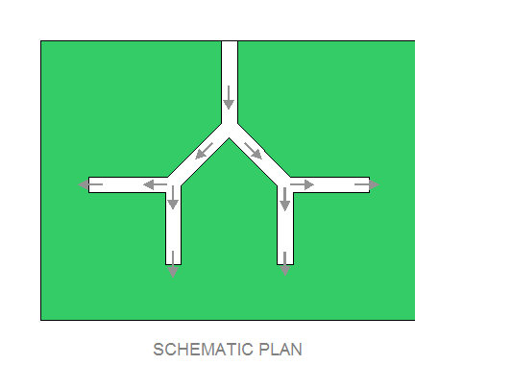

PERCOLATION PIPE TO MULCH BED

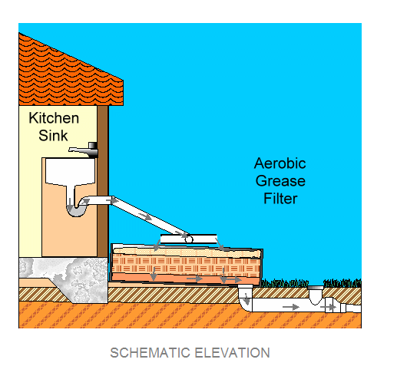

2) Centralized Distribution (Figure 3). In a centralized system, gray water is collected in a storage reservoir or buried tank and then distributed to the points of use using a centralized piping system. A pumped system or dosing siphon requires short term storage. Size the storage tank or dosing siphon to empty at least once per hour during low flow periods. If the distribution system flows by gravity

from the storage tank, then the tank shall be sized to accommodate the maximum volume anticipated during a one day period. Care shall be taken in a pumped system to not start the dosing pump more than 4 times per hour during peak flow periods. The number of pump starts per hour shall be authorized by the pump manufacturer to prevent warranty issues.

**Figure 3. Centralized Gray Water System Concept**

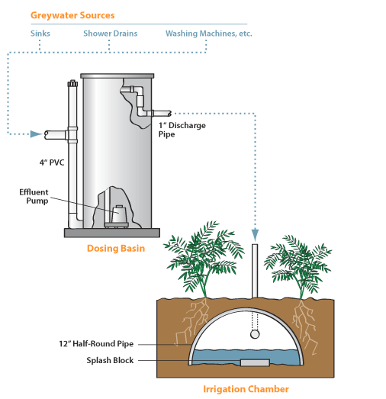

3) System Design Requirements.

aa) Storage. Gray water, when provided, shall be no more than one day of average gray water generation. Provide the storage tank with an access hatch, pump removal mechanism, overflow, bypass, drain piping and valves the necessary to prevent spillage and drain or bypass the tank to a sanitary sewer manhole. Bypass of the system shall be anticipated during wet weather, freezing conditions or maintenance periods.

bb) Pressure Distribution System Design. Provide a force main with a minimum pressure of 34 kPa (5 psi) at each distribution lateral orifice and a maximum effluent main pressure 241 kPa (35 psi). Minimum distribution lateral diameter shall be 50 mm (2-inch). Maximum lateral pipe diameter shall be 100 mm (4-inch). Orifice diameter shall be 3 mm.

cc) Gravity Distribution System Design. Slope gravity drain pipes per Table 4. The design should try to limit maximum fall from building service pipe to point of use to less than 0.8 meter in order to avoid deep infiltration beds that will be below the normal root zone.

**Table 4. Minimum Gray Water Gravity Drain Pipe Slopes**

|  |  |
| --- | --- |
| Gray water Drain Size | Minimum Slope in Meters per 100 Meters |
| 50 mm | 1.50 |
| 100 mm | 1.00 |

dd) Irrigation Requirements. The landscaped area has to be sized considering the limiting native soil percolation rate that should be used in the design of the amount of irrigated area. The design can consider how much gray water can be applied considering as plant evapotranspiration variation throughout the year. This also will require consideration of the root depth for the landscaped vegetation that will be able to utilize the applied wastewater. Onsite septic system effluent disposal drain pipes for non disinfected septic tank effluent are typically buried at depths between 70 to 100

cm (28 to 40 inches) for freeze protection. If the system will be turned off during the winter (nongrowing season) this depth can be decreased. Turf grass root depth is between 30 to 45 cm. However, herbaceous plants and shrubs are capable of achieving 100 cm root depth.

**5. Reuse Systems Under Athletic Fields**

Reuse systems under athletic fields is an option under a number of contracts which were issued in FY07, FY08, and FY09. The concept of using grey and reclaimed water for subsurface irrigation is a proven method of water reuse and conservation of fresh water. While the employment of subsurface irrigation under athletic fields is a practice which has merit and can provide improved surfaces for athletic events, it is also something which can create health hazards and over time, damage the playing surfaces it is intended to support. Continuous irrigation of an athletic field will create soggy and unstable soils which can cause injury to event participants. The subsurface athletic field irrigation system shall NOT be the primary discharge system for the facility wastewater flow. The subsurface athletic field irrigation system may be an alternative discharge point which is utilized at specific and controlled rates and times. It shall be an ALTERNATE and INTERMITTENT location for disposal.

The primary means of disposal must be able to receive 100% of the wastewater flow from the facility when necessary.

The design considerations and requirements for subsurface disposal and irrigation systems previously discussed must be considered when designing a subsurface irrigation system for an athletic field. The designer must determine the water uptake capacity for the field, both surface grasses and subsurface soils, during differing weather conditions. The designer must determine the frequency and duration of flow diversion to the irrigation system during each season or weather period. The designer must design a control philosophy which alerts facility personnel as to when the field is too wet and the flow must be diverted away from the subsurface athletic field irrigation system. The designer must insure that proper signage is posted at the athletic field alerting personnel that a subsurface athletic field irrigation system using reclaimed wastewater is being utilized and that there

is the potential for exposure to human pathogens.

**6. Design Submittal Information**

Design submittal data is summarized in the following Table 6. This information is to be provided with the design submittal for the project and with any submittals related to wastewater treatment system (septic tank, WWTP and lagoon system) design submittals.

**Table 6 Summary of WWTP Effluent & Gray Water Reuse Design Submittal Data**

|  |  |  |
| --- | --- | --- |
| **Parameter** | **Design Value**  **for Proposed**  **System** | **Source or Equation (1)**  **(with supporting calculations)** |
| Average daily reclaimed wastewater flow (ADF) |  |  |
| Peak hour reclaimed wastewater flow (PHF) |  |  |
| Equalization storage volume (1) |  |  |
| Site conditions (irrigation season monthly  precipitation, evaporation, soil types) |  |  |
| Map showing locations of percolation testing within  area proposed for irrigation system (4) |  |  |
| Percolation data (4) |  |  |

|  |  |  |
| --- | --- | --- |
| Landscaping area |  |  |
| Vegetation used in landscaping plan and typical seasonal uptake rate per m2 |  |  |
| Proposed irrigation application rates |  |  |
| Facility site plan showing piping from facility to  irrigation system (3) |  |  |
| Distribution system layout including pipe sizes  (shown on plan) and pipe material |  |  |
| Number and power requirements of dosing pump |  |  |
| Designer selected pump data showing make/model and selected curve with duty point |  |  |
| Proposed reclaimed wastewater flow loadings per  surface area (2) |  |  |
| Primary wastewater disposal location and capacity |  |  |
| Designer shall state all operation and maintenance  requirements & assumptions. |  |  |

Notes: 1. Required for pumped systems

2. If process requires filter, include this loading

3. Reclaimed WWTP effluent reuse system – include WWTP site plan drawing

4. AED Design Guide for Sanitary Systems, latest version.

**7. As-Builts**

Upon completion of installing the reuse system, The Contractor shall submit editable CAD format As- Built drawings. The drawing shall show the final product as it was installed in the field, with the exact dimensions, locations, materials used and any other changes made to the original drawings. Refer to Contract Sections 01335 and 01780A of the specific project for additional details.

**8. References**

1. Guidelines for Water Reuse, U.S. EPA 2004

2. World Health Organization Health Guidelines for the Use of Wastewater in Agriculture and

Aquaculture 1989

3. World Health Organization Guidelines for the Safe Use of Wastewater, Excreta, and Gray water, Volume 4, 2006

4. Engineering Technical Letter (ETL) 08-10: Alternative Water Sources – Use of Non-Potable

Water, HQ Air Force Civil Engineering Support Agency July 2008

5. Wastewater Quality Guidelines for Agricultural Use, Food and Agriculture Organization, 1989

6. AED Sanitary Sewer and Septic Systems Design Requirements, latest version

7. AED Design Requirements - Package WWTP & Lagoons, latest version

8. Army, TB MED 593, Guidelines for Field Waste Management, September 2006.